Exercise 1

package org.example;  
  
public class Calculator {  
  
 public int add(int a, int b) {  
 return a + b;  
 }  
  
 public int subtract(int a, int b) {  
 return a - b;  
 }  
}

TEST

package org.example;  
  
import org.junit.Test;  
import static org.junit.Assert.*assertEquals*;  
  
public class CalculatorTest {  
  
 @Test  
 public void testAdd() {  
 Calculator calc = new Calculator();  
  
 *assertEquals*(7, calc.add(5,2));  
 }  
  
 @Test  
 public void testSubtract() {  
 Calculator calc = new Calculator();  
 *assertEquals*(5, calc.subtract(7,2));  
 }  
}

OUTPUT

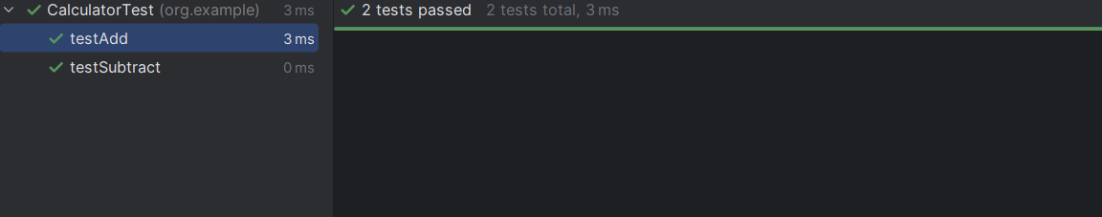

Exercise 2

package org.example;  
  
public class Grade {  
 int marks;  
 public String evaluate(int marks){  
 if(marks>=50) return "you are passed the exam!!";  
 else return "You are failed the exam needs improvement";  
  
 }  
}

package org.example;  
  
import junit.framework.TestCase;  
public class gradeTest extends TestCase {  
  
 public void testPass(){  
 Grade student =new Grade();  
 *assertEquals*("you are passed the exam!!",student.evaluate(75));  
  
 }  
 public void testFail(){  
 Grade student=new Grade();  
 *assertEquals*("You are failed the exam needs improvement",student.evaluate(49));  
 }  
  
}

OUTPUT

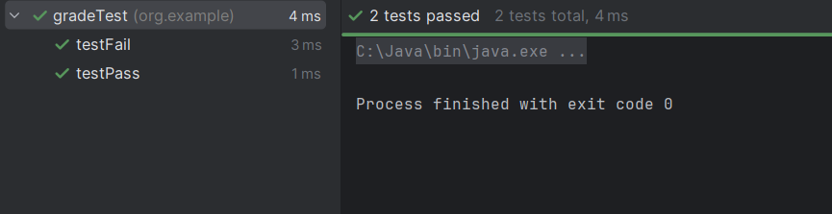

EXERCISE 3

package org.example;  
  
public class Assertion {  
 public int add(int num1,int num2){  
 return num1+num2;  
 }  
 public boolean greater(int num1,int num2){  
 return num1>num2;  
 }  
  
}

package org.example;  
  
import org.junit.Test;  
import static org.junit.Assert.\*;  
  
public class AssertionsTest {  
  
 @Test  
 public void testAssertions() {  
 Assertion obj = new Assertion();  
 *assertEquals*(5, obj.add(2, 3));  
 *assertTrue*(obj.greater(5, 3));  
 *assertFalse*(obj.greater(3, 5));  
 Object obj1 = null;  
 *assertNull*(obj1);  
 Object obj2 = new Object();  
 *assertNotNull*(obj2);  
 }  
}

OUTPUT

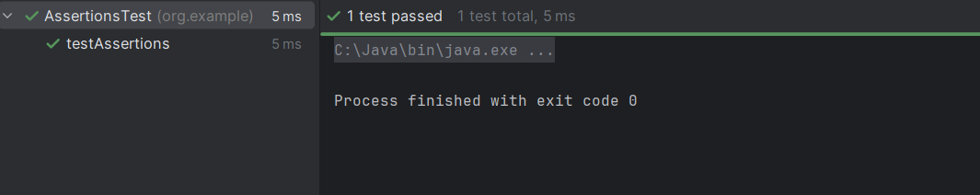

EXERCISE 4:

package org.example;  
  
import org.junit.Before;  
import org.junit.After;  
import org.junit.Test;  
import static org.junit.Assert.assertEquals;  
  
public class AAATest {  
  
 Calculator cal;  
  
 @Before  
 public void setUp() {  
 cal = new Calculator();  
 System.out.println("Execute before the test");  
 }  
  
 @After  
 public void tearDown() {  
 cal = null;  
 System.out.println("Execute after the test");  
 }  
  
 @Test  
 public void testAdd() {  
 int a = 5;  
 int b = 4;  
 int res = cal.add(a, b);  
 assertEquals(9, res);  
 }  
}

